**Hosting a website on Github**

**Step 1:** **Create your own webpage.**

**Step 2: Sign Up for a Github account.**

* Visit github.com and fill the form and sign up for GitHub. The username you choose will be publicly viewable on the URL of your website as yourusername.github.io.
* Choose a free plan and verify your email address.

**Step 3:** **Create a Github project for your website.**

* Once you verify your email address, Click Start a project. Write the name of your project in the Repository name.
* If you already have a GitHub account then make a new repository for your website. The repository name will be included on the URL of your website as yourusername.github.io/repositoryname.

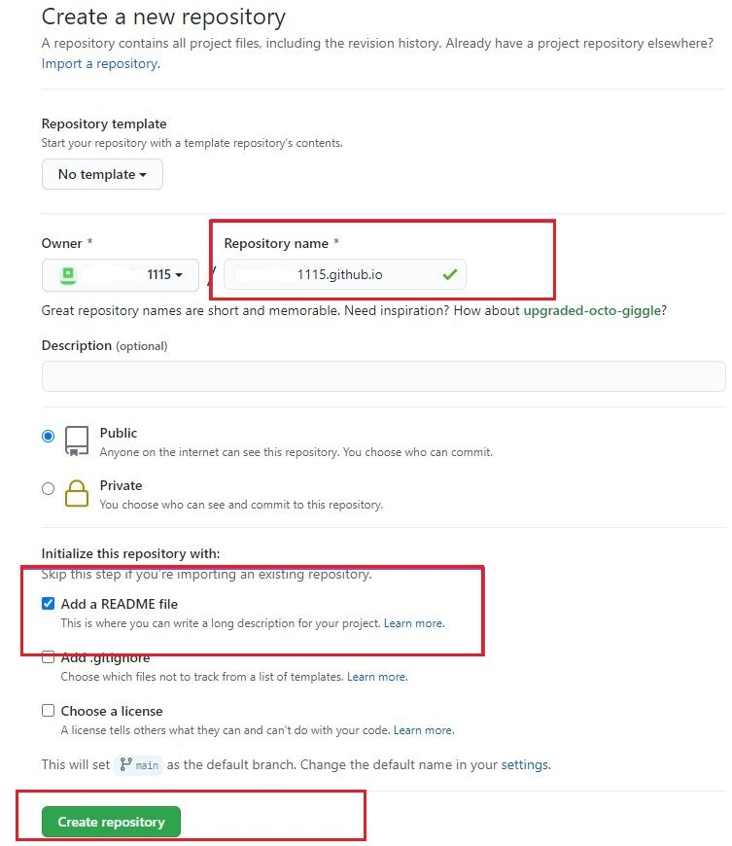

* Click on the “README” link in the Code section, then the file editor interface of a file named README.md is opened. Change the filename from README.md to index.html. Servers accept index.html to be the name of the main file of a website folder.



* Delete the current contents of the file editor and replace them with the HTML (do copy paste of your code) of your webpage

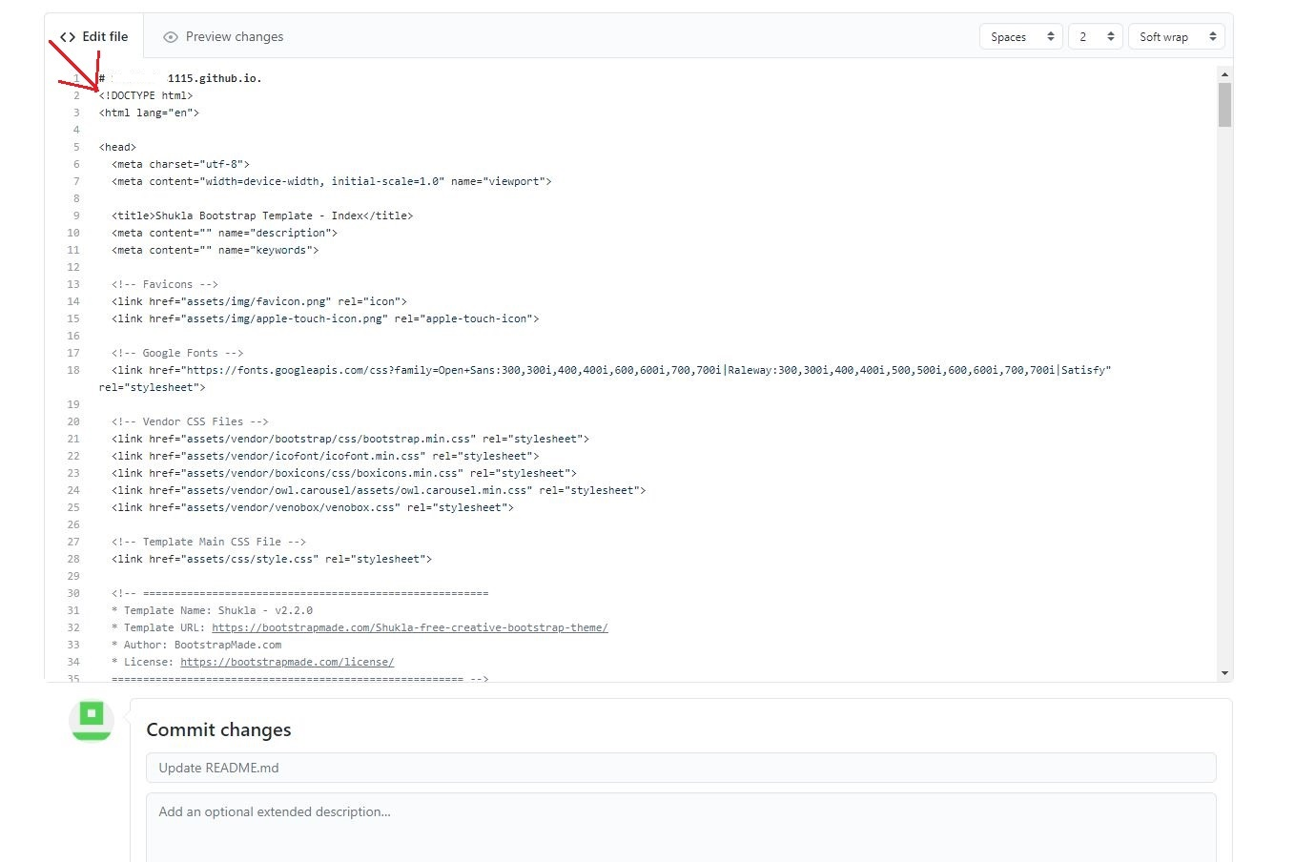

* Once you are done, scroll down and click “Commit new file”.

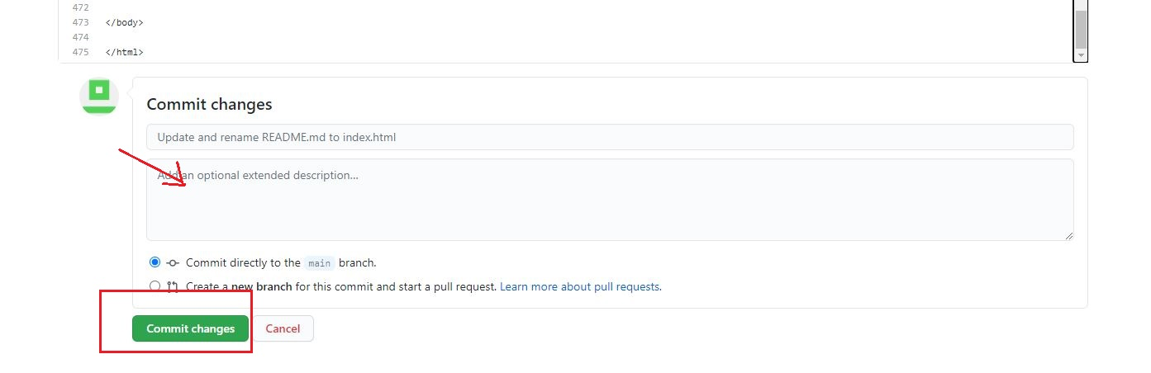

* If you need to upload other HTML files or resources then Click Add file and click upload files and then drag-and-drop all the required files into Github.

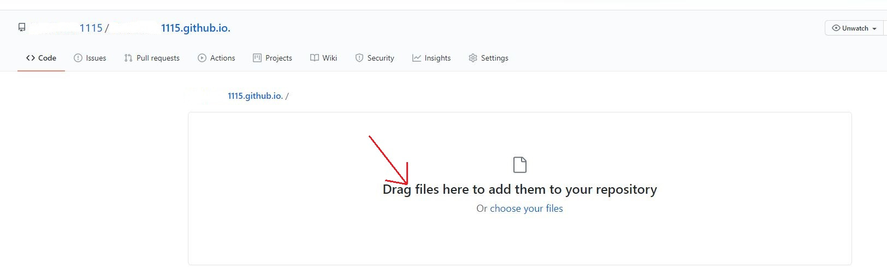

* Once uploaded click commit changes. Now you have all the required files uploaded on Github.

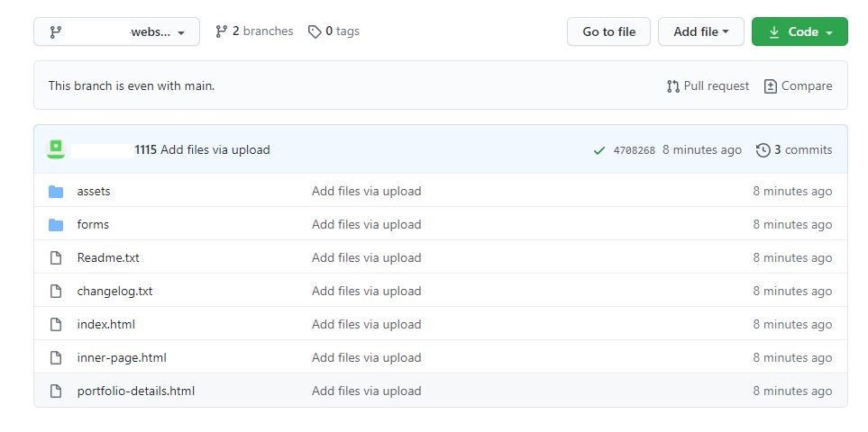

* Go to Settings, in the Github pages section choose branch name, and save it.
* Then you will get your site for your webpage at the Github pages section. The site will be as https://yourusername.github.io/repositoryname/. Load that site in your browser. Remember that it might take up to 10 minutes to load the webpage.

